**Status Checks**

Launch instance ---> Amazon linux ---> Review and launch (Take the default options)

Observe the status check - Initializing, 2/2 checks passed



In availability zone, we have physical hard disk.

On top of physical hard drive ---> we have virtualization software (Xen hypervisor)

On Virtualization software, we have Ec2 machine

What is the meaning of 2/2 check passed?

**check 1** - Instance status check - The instance is running and healthy.

**check 2** - System status check - The hardware of the instance is healthy.

* 1/2 checks passed:
  + Check 1: Instance status check - The instance is not running.
  + Check 2: System status check - The hardware of the instance is healthy.
* 0/2 checks passed:
  + Check 1: Instance status check - The instance is not running.
  + Check 2: System status check - The hardware of the instance is not healthy.
* When system status (hardware) is failed, obviously instance will fail.

**Troubleshooting Instance Status Checks**

* 1/2 checks passed:
  + Solution: Reboot the instance. This will reload the operating system and may fix the problem.
* 0/2 checks passed:
  + Solution: Stop and start the instance. This will migrate the instance to a new physical machine, which may fix the hardware problem.

Select the instance---> Status check tab

We can see System status check and instance status check

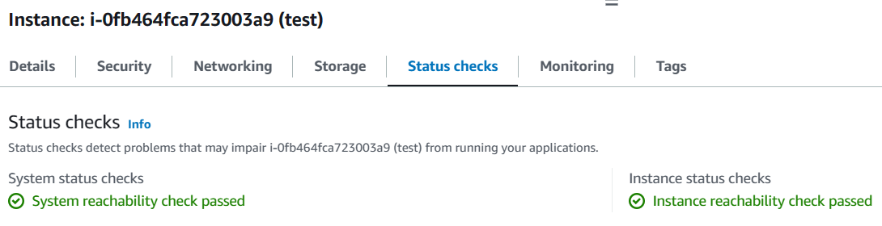

**Protecting Instances from Accidental Termination**

To protect an instance from accidental termination, you can enable termination protection. This will prevent the instance from being terminated unless you explicitly disable termination protection.

Go to actions ----> instance settings ---> change termination protection --> yes, Enable

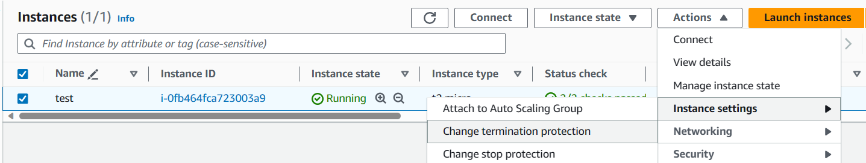

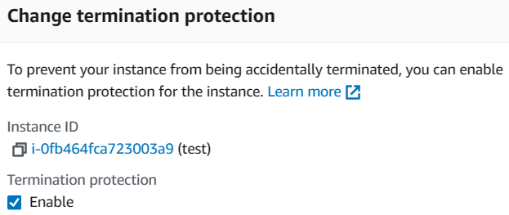

Now, we cannot terminate the machine.

In case you want to terminate, just disable change termination protection

**Understanding Scale Up and Scale Out**

* Scale up (vertical scaling):
  + Adding more resources to an existing machine to increase its capacity.
  + Example: Adding more RAM or CPU cores to an instance.
* Scale out (horizontal scaling):
  + Adding more machines to distribute the workload and increase capacity.
  + Example: Adding more instances to a load balancer.
* **Note:** Auto scaling comes under scale out

**Scale Up and Scale Down in AWS**

AWS supports scale up. Once an instance is created, you can increase or decrease its hardware resources (CPU, RAM, HDD).

**How to Scale Up an Instance**

1. Stop the instance.
2. Go to Actions > Instance settings > Change instance type.
3. Select the new instance type.
4. Click Apply.

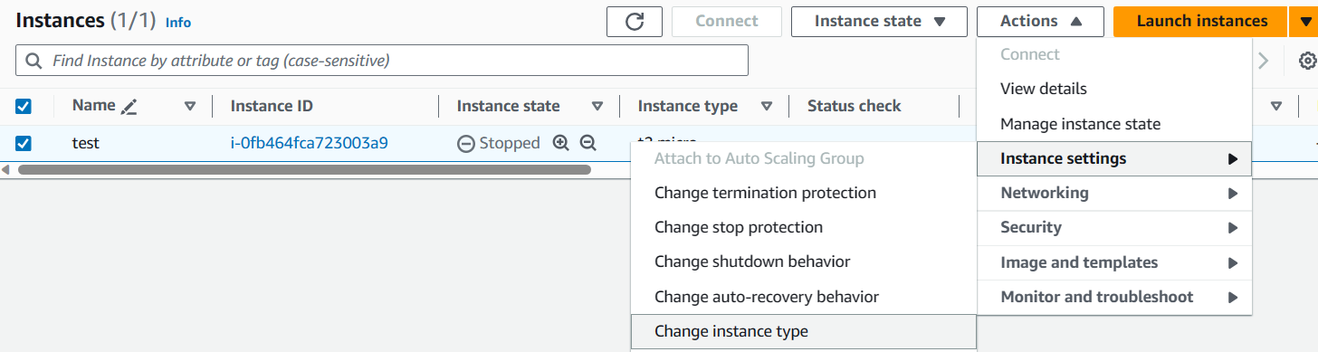

**How to Scale Down an Instance**

1. Stop the instance.
2. Go to Actions > Instance settings > Change instance type.
3. Select a smaller instance type.
4. Click Apply.

**How to Scale Up or Down Hard Disk**

To increase the hard disk, we do not need to stop the machine.

Machine can be in running state.

1. Go to the Volumes dashboard.
2. Select the volume you want to scale.
3. Go to Actions > Modify Volume.

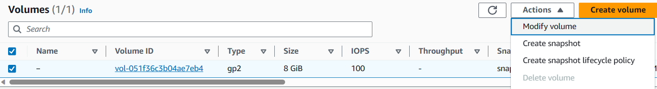

1. Change the Size to the desired value.
2. Click Modify.

It will take time to reflect.

**Attaching Volumes**

1. **Launch an instance:** Select the desired instance type and configure the storage settings.
2. **Add new volumes:** Click on "Advanced" in "Configure Storage." Choose the appropriate volume type, size, and volume details.



1. **Observe Delete on termination:** This option determines whether the volume should be deleted when the instance is terminated. By default, only the root volume (C: drive) is deleted.

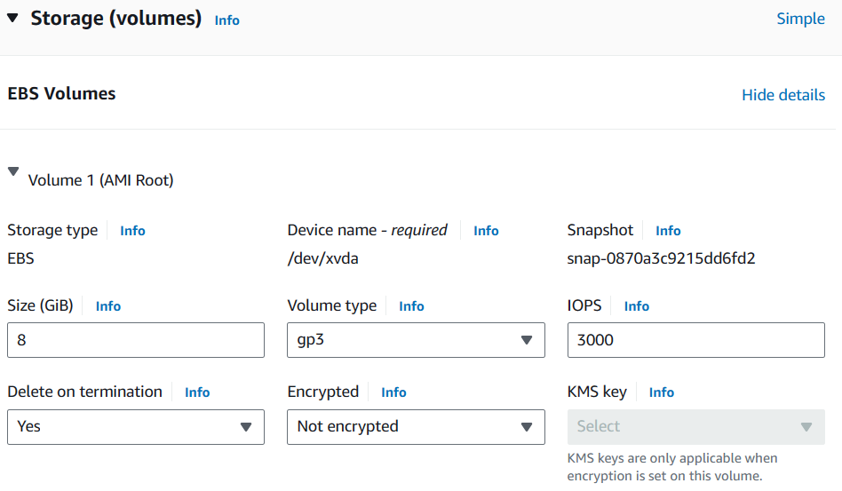

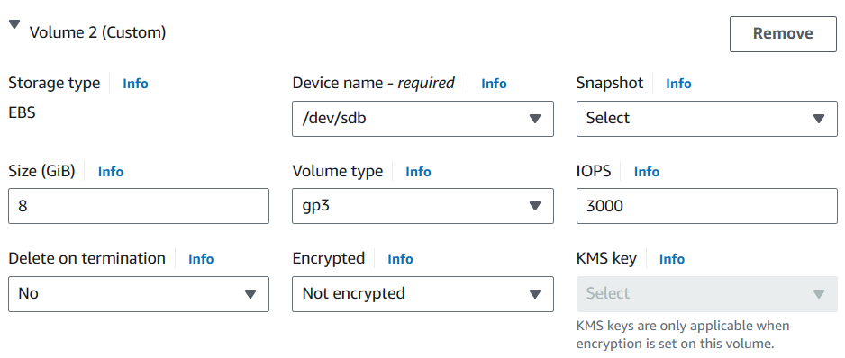

1. **Attach volumes:** Go to the "Volumes" dashboard and select the volume you want to attach. Choose "Actions" > "Attach Volume" and select the instance you want to attach the volume to.

**Detaching Volumes**

1. **Stop the instance:** If you want to detach the root volume (C: drive), you need to stop the instance first.
2. **Detach volumes:** Go to the "Volumes" dashboard and select the volume you want to detach. Choose "Actions" > "Detach Volume" and confirm the detachment.
3. **Attach volumes to other instances:** The detached volume will become available and can be attached to another instance using the same process as attaching a new volume.

